Citrix Sharefile –
User Guide

Table of Contents
1) Version Control 3
2) User Guide Purpose 3
3) Citrix ShareFile Description and Use Cases 3
4) Technology and licensing considerations 3
5) Responsibilities and Functions entitlement 4
6) Access ShareFile 5
a) Web access 5
b) Windows Explorer access 6
7) Enabling ShareFile Outlook Add-in 10
8) Generic components, artifacts, and similarities 14
a) Key Components 14
b) Artifacts 15
c) Online Training 16
d) Functionalities NOT to use 16
e) Links 16
f) Files Expiration 16
9) Create Client account 16
10) Create Root Folders – Admin and IT only 18
11) Add Client or Engagement team member to Folder 21
12) Remove Client or Engagement Team Member from one folder 24
13) Remove Client or Engagement Team Member from All Folders 25
14) Delete Client or Engagement Team Member from System 25
15) Requesting Files 26
a) Email add-in 27
b) Getting a Link from Web interface 28
c) Getting a link from Citrix Files 30
16) Share a Folder 31
a) Email add-in 31
b) Getting a Link from Web interface 33
c) Getting a link from Citrix Files 34
17) Right Signature Integration 35
a) RightSignature launch from ShareFile Web interface 35
b) RightSignature Launch from Citrix File 36

- Version Control
Version | Changes Description | By | Date
1 | Original Version | Severin PIETRI | 7-Nov-2022
2 | Minor grammatical changes; Minor wording changes for clarification purposes | Michael Hubber | 7-Feb-2023

- User Guide Purpose
The purpose of this User Guide is to provide the necessary information to operate the Firm’s implementation of Citrix ShareFile.

- Citrix ShareFile Description and Use Cases
Citrix ShareFile is a cloud based document sharing application with additional components allowing to securely request and share documents with our clients.
The system integrates with Outlook and Windows Explorer for ease of use and efficiencies.
General Use Cases
Citrix ShareFile is to be used for the following cases:
- Create a data repository for sharing information both ways with clients
- Sending securely a one time document to a client using Outlook
- Sending signature request on documents to clients (integrates with Citrix Right Signatures)
- Technology and licensing considerations
For security reasons, our Citrix Sharefile tenant has been configured to only allow connection from our Citrix environment. Meaning you will NOT be able to access it from outside Citrix.
Licensing has three components explained below:
- Clients access and license: we have an unlimited number of client licenses. A client is defined as a user with an email address from any domain but crowemackay.ca
- ShareFile: access to ShareFile requires a license to be assigned to the user. License assignment is managed by IT, and access requires MD approval, for cost control
- ShareFile e-signature (Right Signature): licenses are assigned independently from ShareFile licenses. License assignment is managed by IT, and access requires MD approval, for cost control

- Responsibilities and Functions entitlement
The operation of the Firm’s Citrix ShareFile is as follow:
Functional User Group | General Responsibilities | Functional Entitlement
IT Helpdesk | - Assignment of ShareFile and RightSignature licenses  - Manage shared configuration items (signature and folder templates)  - General support to other groups | - Create users within the firm domain name  - Assign/de-assign ShareFile and RightSignature licenses  - Manage clients (create-delete-inactivate)  - Manage Distribution Groups (e.g. VAN Admin, YEL Admin….)  - Run reports  - Manage Folders’ Templates  - Manage e-signature templates
Admin Teams | - Manage the end-to-end data sharing process with clients, and for High Volume – Standardized processes i.e., T1, T2, YE/NTR…  - May manage data sharing process for infrequent processes: special projects, insolvency data-room…  - Support engagement teams to execute operations on the system to which they do not have access | - Add clients folders in ShareFIle  - Manage clients (add/remove/inactivate)  - Manage accesses to client folders  - Request documents  - Share documents  - Request e-signature (if licensed)  - Access ShareFile via Windows Explorer
Engagement teams | - Manage the end-to-end data sharing process for low volume – low standardization processes i.e. Audit, Special engagements… | - Request documents  - Share documents  - Request e-signature (if licensed)  - Access ShareFile via Windows Explorer

- Access ShareFile
ShareFile can be accessed via your Chrome browser in Citrix or via the Windows Explorer add-in
  - Web access
Follow the steps below to access ShareFile via web browser
- Navigate to https://cmclientportal.sharefile.com
- Click on the left [Sign In] button: 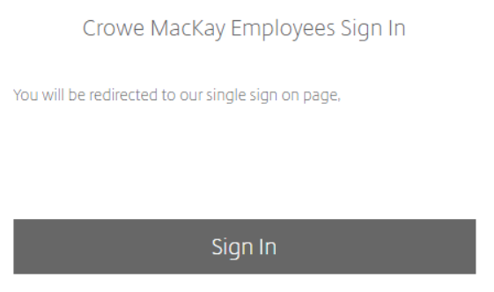
- Complete the Okta authentication process.
- You should see a screen as follow once logged in: 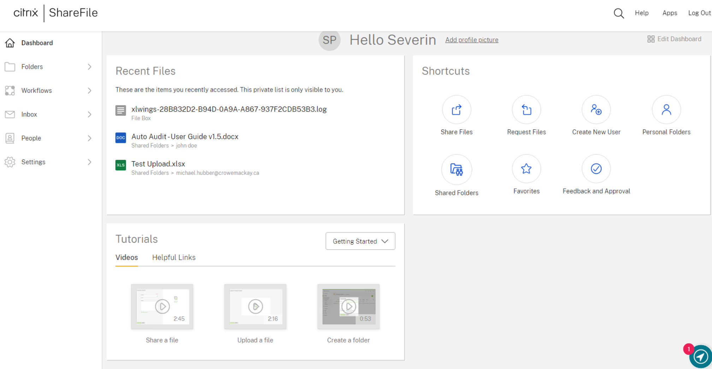
  - Windows Explorer access
Follow the steps below to access ShareFIle via the Windows Explorer App
- Go to your tray icon, find the icon 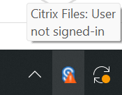 and click on it You may have to click on the “Expand” up arrow 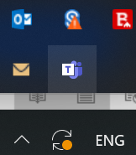
- If the icon is not visible, launch the app via Citrix StoreFront by clicking on: 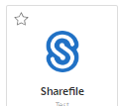
- Click on [Sign In]
- Enter “cmclientportal” in the text box and click [Continue] 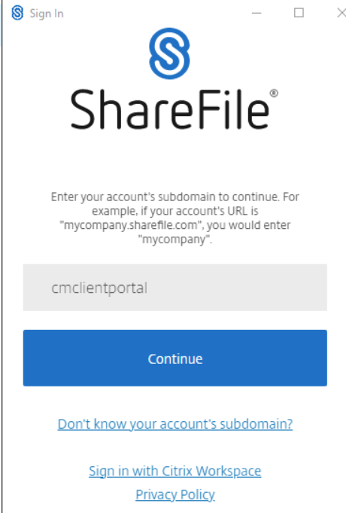
- Click on 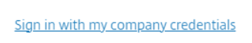
- Complete the Okta authentication process
- If you connection was successful, the window will close and the tray icon will show as 
- Click on the icon  on the top right to Open the folders in Windows Explorer 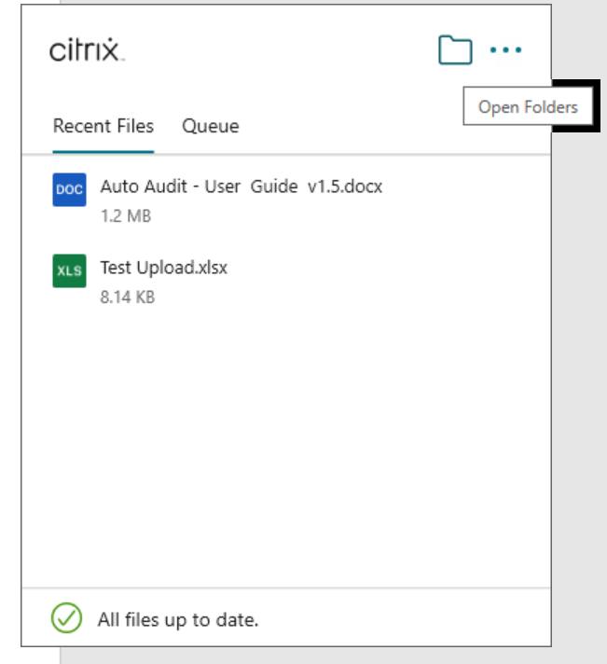
- The ShareFile folders appear as a Z: drive 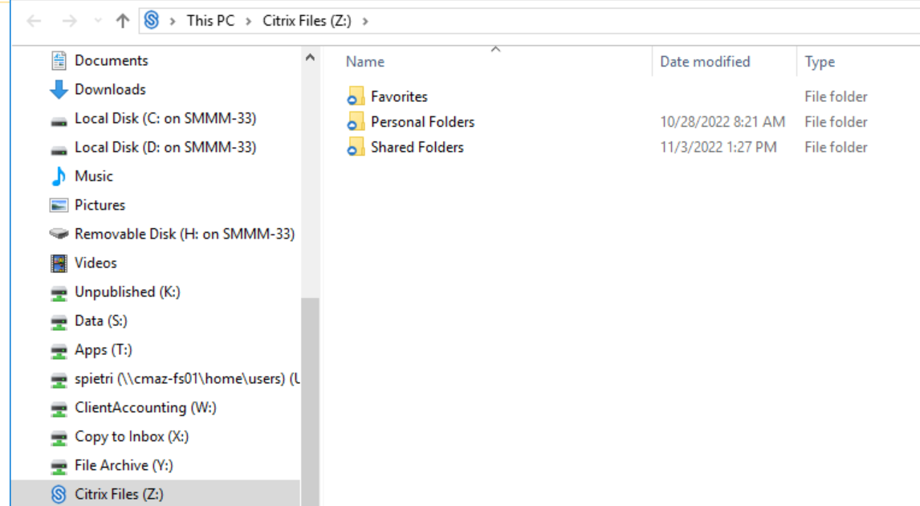
- Enabling ShareFile Outlook Add-in
ShareFile Outlook Add-in allows you to request and share files directly from an outlook e-mail.
Follow the steps below to enable it:
- Click on [File] 
- Click on 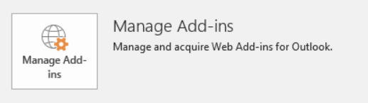
- Outlook will launch in a web browser and show a selection of add-ins 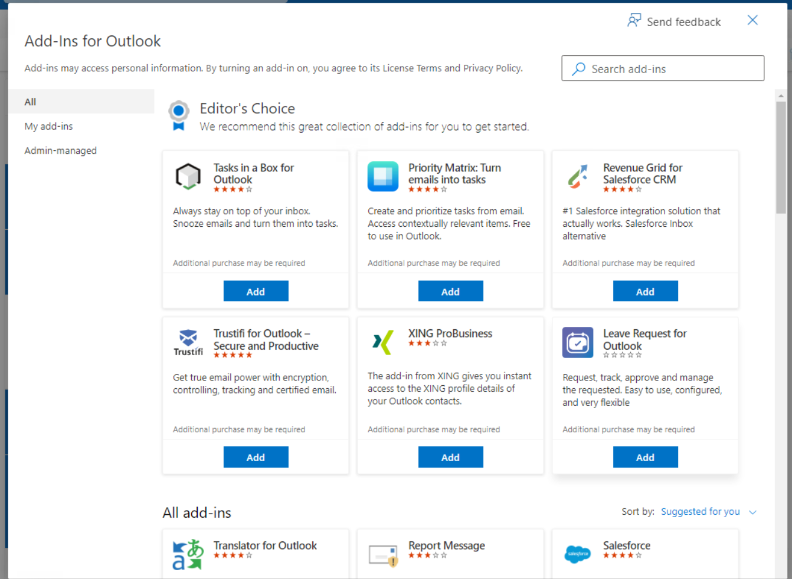
- Select [Admin-managed] 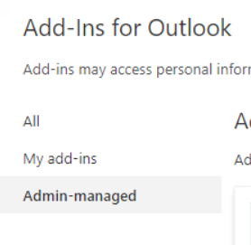
- Click on [Add] in the Citrix Files 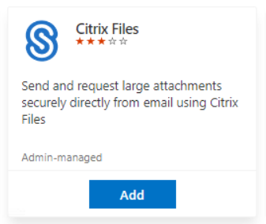
- Click [Continue] 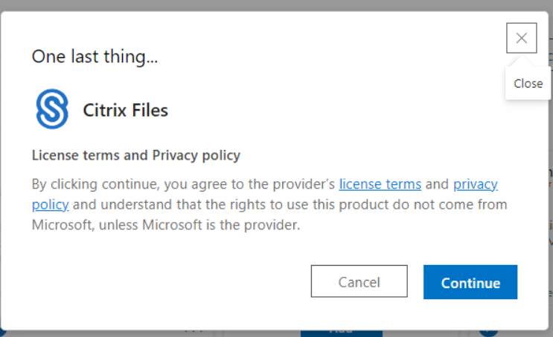
- Close outlook web browser.
- NOTE: if you are already logged in Outlook, you will have to log out of your Citrix session completely and log back in to enable the add-in
- The add-in will appear on a NEW email window only and appear as: 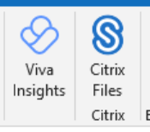 (more on usage later)
- Click on the Citrix Files logo to log in
- Click on 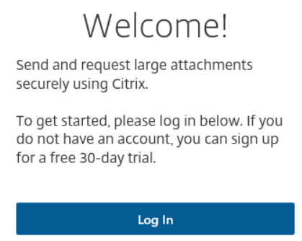
- A pop up will appear, enter cmclientportal in the text field and click [Continue] 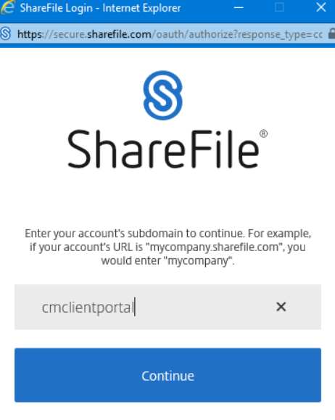
- Click on [Sign in with my company credentials] 
- Complete the Okta authentication
- If successfully logged in you should see a screen like: 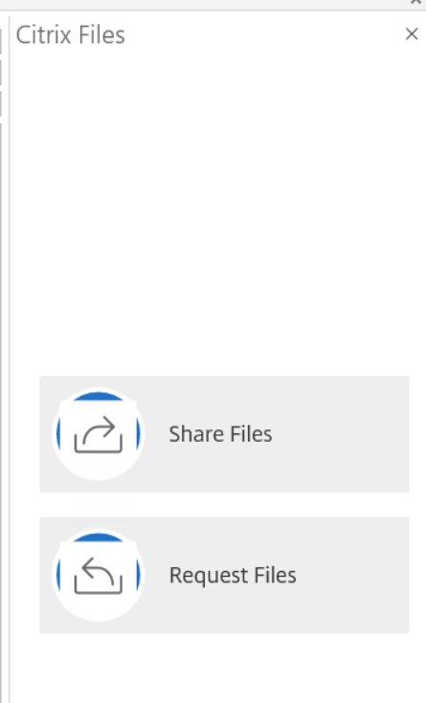

- Generic components, artifacts, and similarities
In this section we will describe the key components, artifacts, and similarities between the different ShareFile components.
As discussed above, you can access ShareFile via a web browser, via windows explorer and interact with it via Outlook.
In respect of interacting with clients, which ever methodology you use will result in the same result, meaning, please use the approach you are the most comfortable with.
NOTE: to avoid overcrowding the user guide, we will only show how to operate from the Windows Explorer component, same logic and principles apply to the web based interface.
  - Key Components
Your ShareFile account has 3 root folders:
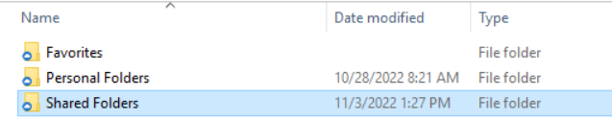
- Shared Folders: This is where all clients folders are created, there is no sub-categorization by office. You will only see the folders to which you have access.
- Personal Folders: are to be used in cases where you are to share or request documents with a third party outside of a normal process i.e. the client does not have a ShareFile assigned folder. By default email based requests will leverage this folder. HOWEVER, you will still need to have the client created as a user before you can share with them. WARNING! Sending requests through this folder will make the data unavailable to the rest of your team or the admin team. Only IT will be able to access it in case of issues. (more on best practices later)
- Favorites: allows to keep links to documents or folders you use often
  - Artifacts
When operating in Windows Explorer, any activity that is related to the ShareFile application has the ShareFile logo on its left:
The available actions will be different depending on the object selected and where you right click.
NOTE: Be sure to right click on the object you want to interact with.
  - Online Training
In the web based app, you have numerous links to videos to show you how to use the application.
Please feel free to go through them, they cover the key functionalities
  - Functionalities NOT to use
ShareFile has a few other functionalities, that while they seem active, they will not operate adequately due to our security set up, they are:
- Workflows – Feedback and Approval
- Workflows – Request List

  - Links
ShareFile operates on the concept of Links.
Links are what is sent to clients to request a set of files or to share files.
Links require recipients to provide their name and email as to interact with ShareFile, this is for tracking purpose.
Links are made to expire after 7 days. This behavior cannot be changed.
However, while a link expire, clients can still log-in via https://cmclientportal.sharefile.com and access the folders they have been given access to.

  - Files Expiration
ShareFile is a data sharing / data transfer and is not intended as a long term repository for client’s data. Consequently, files will be automatically purged, without warning, after 6 months.

- Create Client account
Only Admin team members and IT can create Clients accounts
NOTE: you can create clients via the web interface directly OR via Web and Citrix Files interface through “Manage Permissions”, The user guide shows via the Web; other methods are similar
- Click on [People>Manage Users Home] 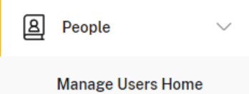
- Click on 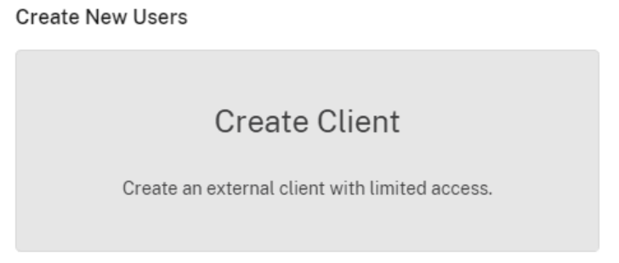
- Fill the form 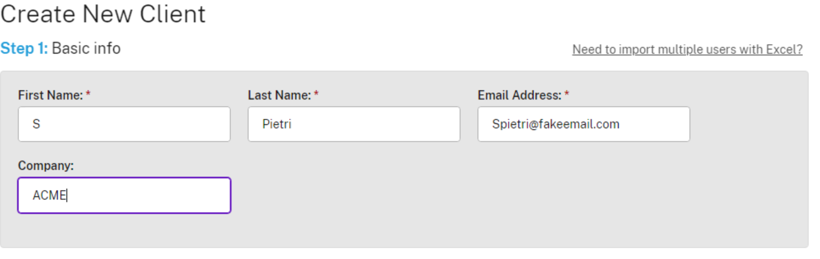
- If you want to add more than one user at a time with access to same folder, click on
- If the Client folder is already created, then you can click on [Assign Folders] and follow the directions. Please refer to the section [Grant Access to Folder] below regarding settings.
- DO NOT USE [Add to Distribution Group] or [Copy Folder Access from Existing User] these actions are Dangerous and often result in unwanted access being granted
- Click on 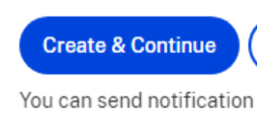
- Update or leave as-is the message for the notification email to inform clients they have been added to ShareFile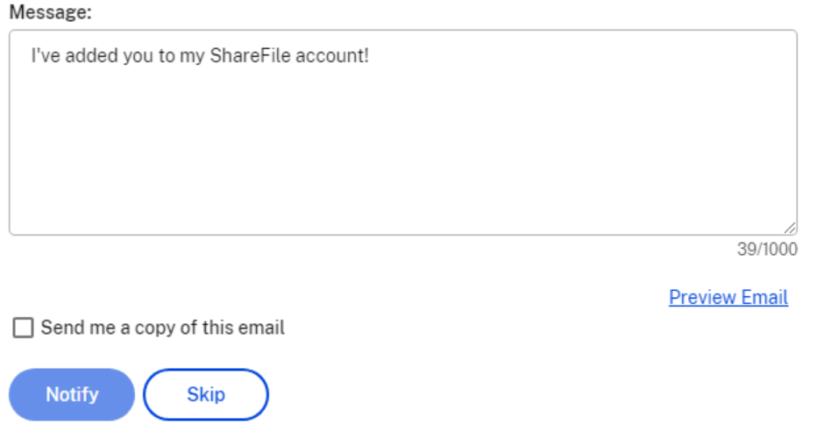
- You can Preview the email by clicking [Preview Email] 
- Click 
- If you need to resend the email notification, follow the action:
  - Click on [People> Browse Client]
  - Click on the Client’s name
  - Click on [Email Login Information] 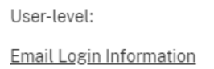
  - You will be back to point 8 above.

NOTE: Emails sent by Sharefile come from mail@sf-notifications.com, ensure your clients whitelist this domain

- Create Root Client Folders – Admin and IT only
Admins and IT are the only users that can create root client folders
You can create folders via Web and via Citrix File
However, when creating a folder from the Citrix File, you can not assign a Template, consequently we do not recommend you create it from the Citrix Files.
Also the Manage Permissions/ Add user functionality is more streamlined in the Web Interface
To create a root folder using the web interface follow steps
- Click on [Folders> Shared Folders] 
- Click on 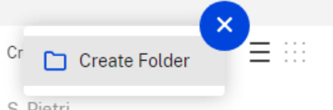
- Enter the name of the folder, abide to following naming convention:
  - Corporate client: Use the same name as the CaseWare folder
  - Personal Client: Client name followed by the email address, replacing the @ by a _ like: Dr John Smith – drjohnsmith_gmail.com this is to reduce the risk of granting access to the wrong folder.
- Select the “Add People to Folder”
- Select [Use a folder template] and select the template you want to use
- Screen should look like: 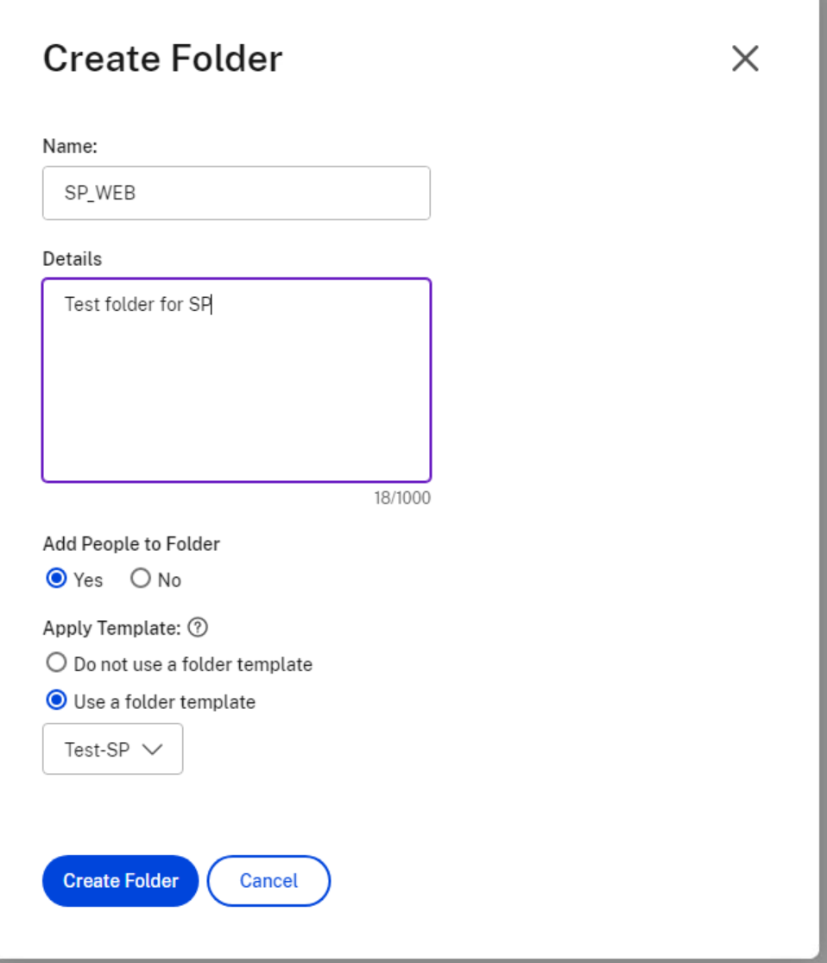
- Click [Create Folder]
- First we add the Admin Group for the relevant office
  - The “Add People to Folder” pop up will appear.
  - In the [Select] box, type the name of your Admin office group 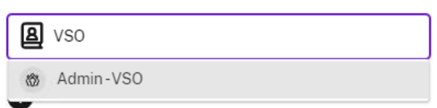 and click on it
  - For Folder Permissions – Select: View, Download, Upload, Delete, Admin.
  - WARNING: NEVER SELECT ADMIN WHEN ADDING A CLIENT or ENGAGEMENT TEAM MEMBER
  - For Folder Alerts – Select: “Email users when files are uploaded”.
  - WARNING: If you do not select this option, you will not receive alerts when clients load files!
  - Unselect “Notify added users”
  - Select “Apply settings to subfolders”
  - WARNING: not selecting this option will not give access to the subfolders of the client folder!!
  - The screen should look like: 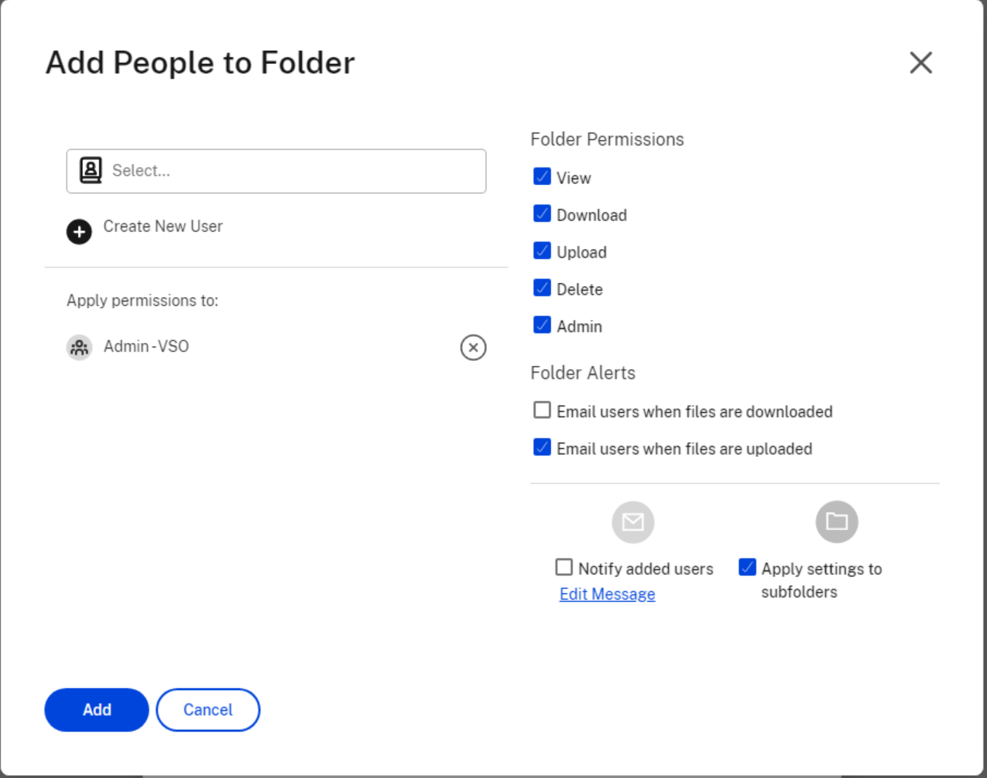
  - Click [Add]
  - You should be redirected to the folder

- Add Client or Engagement team member to Folder
You can add a client to a folder via the Web or the Citrix Files interface, we will only discuss the Web interface, however exactly same steps work on the Citrix Files interface
- Go to [Shared Folders] and click the folder you want to enter
- Select the tab [People on this Folder] 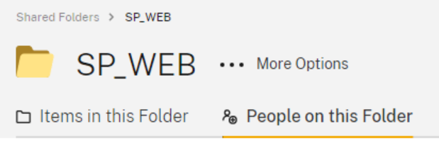
- Click [Add People to Folder] 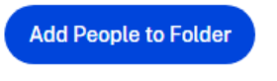
- Search for the Client on the Select box 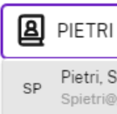 and click on the name. You can search by email address also. You can select more than one user at the same time
- If required, you create a user from this screen by clicking 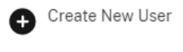
- For Folder Permissions – Select: View, Download, Upload, Delete.
- WARNING: NEVER SELECT ADMIN WHEN ADDING A CLIENT or ENGAGEMENT TEAM MEMBER
- For Folder Alerts –
  - We propose the following depending on type of user:
    - CLIENT: Un-Select
  - If you want the engagement team to receive an alert once files are uploaded then Select: “Email users when files are uploaded”. Probably best when you want to keep control on when to inform a client files are ready
  - If you do NOT want the client to receive an alert once files are uploaded then UN-Select: “Email users when files are uploaded”. Probably best when you want to keep control on when to inform a client files are ready. i.e. more personalized message than
- WARNING: If you do not select this option, you client/engagement team will not receive alerts when clients load files!
- Select “Notify added users”
- Select “Apply settings to subfolders”
- WARNING: not selecting this option will not give access to the subfolders of the root folder!!
- The screen should look like: 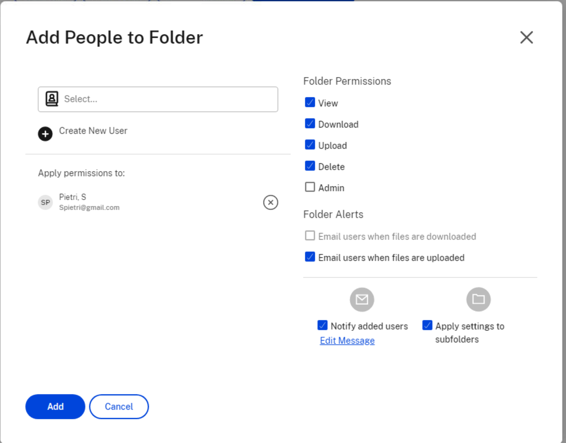
- Click on [Edit Message]
- Modify the message to make it relevant on the purpose of the folder: e.g.,” I have added you to a folder that will be used for transferring data between you and us”
- Click [Done]
- Click [Add]
- You should be redirected to the folder

NOTE you can access the permission screen via Citrix Files by
- Citrix Files: Navigate to the root folder and Right click on the desired folder and select [More Options > Manage Permissions] 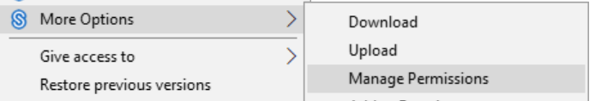

- Remove Client or Engagement Team Member from one folder
Following step to remove users from one Folder
In Web Interface
- Go to [Shared Folders] and click the folder you want to enter
- Select the tab [People on this Folder]
- Check the checkbox for the user(s) you want to remove 
- Select
- Click 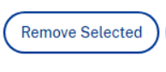
- Click Remove in the confirmation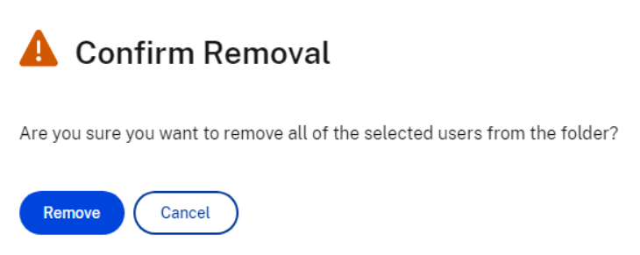
NOTE you can access the permission screen via Citrix Files by
- Citrix Files: Navigate to the root folder and Right click on the desired folder and select [More Options > Manage Permissions]

- Remove Client or Engagement Team Member from All Folders
NOTE: only IT helpdesk can remove a user from all folders in ShareFIle.
If you need a user (client or engagement team member) to be removed from ShareFIle, please create an IT Helpdesk ticket and provide the user email address.
You can remove all the folder accesses for one user in one operation
In Web Interface
- Go to [People > Browse Clients] 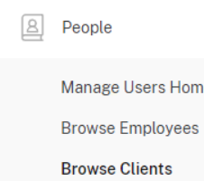 for clients or 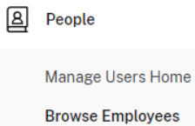 for employees
- Search or browse to the desired client or employee
- Click on the name
- Click on 
- Click on 

- Delete Client or Engagement Team Member from System

NOTE: only IT helpdesk can delete a user from all folders in ShareFIle.
If you need a user (client or engagement team member) to be deleted from ShareFIle, please create an IT Helpdesk ticket and provide the user email address.
You can remove a client or an engagement team member (only IT can) from the system
In Web Interface
- Go to [People > Browse Clients] for clients or for employees
- Search or browse to the desired client or employee
- Click on the name
- Click on
- Click on 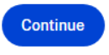

- Requesting Files
WARNING: The Request a File functionality allows to have a client load a file into another client folder if you do a mistake in sending the request to the wrong user!! Consequently We prefer your Share a folder with a Client and ask them to put the data there
Requesting files can be done through 3 diverse ways: web interface, Citrix Files, and Email add-in
All rely on the creation of a link that is then shared with the client.
Both the Web interface and Citrix Files, allow you to do a “Request With Citrix”. By using these functions, the request email will come from Sharefile without our standard foot notes. Also you are much more limited on the wording you can add to the email, consequently we recommend you create an email and include the link
  - Email add-in
Follow steps below to get a link and send a request via email:
NOTE: due to the lack of Search function for a client folder in this process, we do not recommend it.
- In a new email: Enter the email address you want the link sent to in the email To… field. NOTE: please ensure the recipient already has an account in our ShareFile
- Then click on 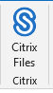
- Then click on: 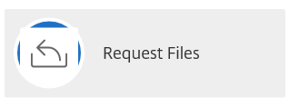
- Select if you want to receive a notification once files are uploaded: 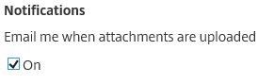
- Be sure to click on [Edit], 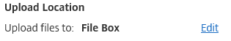 if not the client will be asked to load a file in your personal File Box and not the client folder.
- Select the folder where you want the client to provide the data 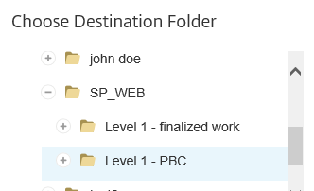
- Click 
- In the email body, put your cursor where you want the link inserted:
- The click 
- You will receive a notification indicating that “Require Sign in”. this is the desired behavior. Click
- The link will have been added as: 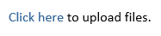
- Complete the email and send to client.
  - Getting a Link from Web interface
To get a link from the web interface there is two ways that bring you to the same process
- FROM SHARED FOLDERS
  - Right click on a shared folder where you want the client to load data and select [Request Files] 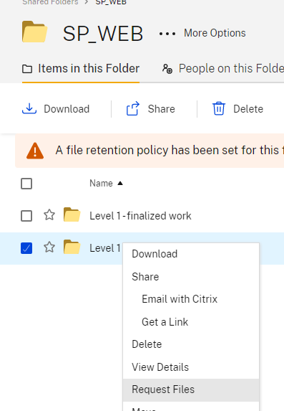
  - Click on [Get a Request Link] 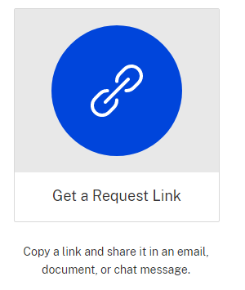
  - Click on 
  - Select if you want to receive notification once data is loaded: 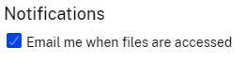
  - Leave the other items as is. NOTE: Whatever setting you select for [Who can access this link], a security policy will overwrite your choice to 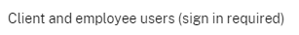
  - Click 
  - Click 
  - Click 
  - Paste the link into your email or word document, or chat…
- FROM DASHBOARD
  - NOTE: due to the lack of Search function for a client folder in this process, we do not recommend it.
  - Getting a link from Citrix Files
You can get a link directly from the Citrix Files explorer
- Browse to the folder you want the client to load data into
- Right click on the folder and select [Request>Get a Link]
- Click 
- Select if you want to receive notification once data is loaded 
- Select Expires [six months] or less 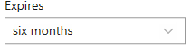
- The “Who can access this link” option is overwritten by a policy to
- Click 
- Click 
- Paste the link to the email or messaging

- Share a Folder
Sharing a folder (or file) can be done through 3 diverse ways: web interface, Citrix Files, and Email add-in
All rely on the creation of a link that is then shared with the client.
Both the Web interface and Citrix Files, allow you to do a “Email With Citrix”. By using these functions, the request email will come from Sharefile without our standard foot notes. Also you are much more limited on the wording you can add to the email, consequently we recommend you create an email and include the link
  - Email add-in
Follow steps below to get a link and send a request via email:
NOTE: due to the lack of Search function for a client folder in this process, we do not recommend it.
- In a new email: Enter the email address you want the link sent to in the email To… field. NOTE: please ensure the recipient already has an account in our ShareFile
- Then click on
- Then click on: 
- Click on [Browse Files > From Citrix] 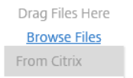
- Select the folder where you want the client to provide the data
- Click 
- If you want to share more than one location or more than one file, click on 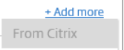
- In the email body, put your cursor where you want the link inserted:
- The click
- You will receive a notification indicating that “Require Sign in”. this is the desired behavior. Click
- The link will have been added as: 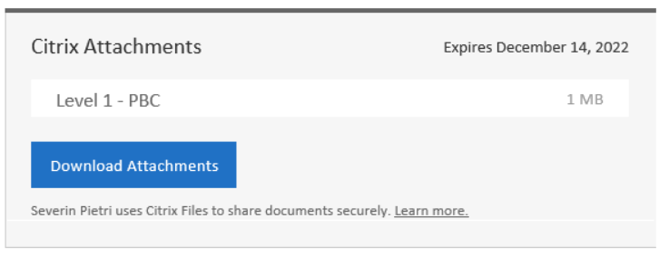
- Complete the email and send to client.

  - Getting a Link from Web interface
To get a link from the web interface there is two ways that bring you to the same process
- FROM SHARED FOLDERS
  - Right click on a shared folder where you want the client to load data and select [Share > Get a Link] 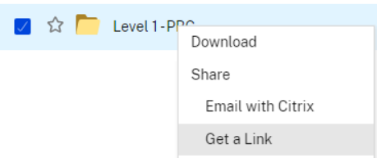
  - Click on
  - Select if you want to receive notification once data is loaded:
  - Leave the other items as is. NOTE: Whatever setting you select for [Who can access this link], a security policy will overwrite your choice to
  - Click
  - Click
  - Paste the link into your email or word document, or chat…
- FROM DASHBOARD
  - NOTE: due to the lack of Search function for a client folder in this process, we do not recommend it.
  - Getting a link from Citrix Files
You can get a link directly from the Citrix Files explorer
- Browse to the folder you want to share
- Right click on the folder and select [Request>Get a Link]
- Click
- Select if you want to receive notification once data is loaded
- Select Expires [six months] or less
- The “Who can access this link” option is overwritten by a policy to
- Click
- Click
- Paste the link into your email or word document, or chat…

- Right Signature Integration
ShareFile allows you to select a file to send for e-signature directly from Sharefile.
You will only be able to do so if you have a RightSignature license assigned to you
You can launch the Right Signature process from the Web interface or the Citrix Files app.
  - RightSignature launch from ShareFile Web interface
You can launch the Right Signature process from the ShareFile web interface
- Browse to the file you want to process via RightSignature
- Right click and select 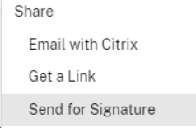
- You will be redirected to the RightSignature web interface.
- Process file as usual
- The file will have a  on its line in ShareFile, clicking on the icon will provide with a status on the file: 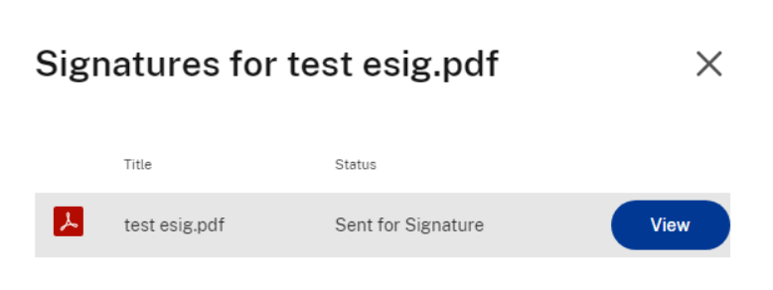
- Clicking on  will open RighSignature again
- Once the file is Signed by all parties a new file will appear in ShareFile with “signed-certificate” at the end. 
- This file contains the signed version AND the certificate
  - RightSignature Launch from Citrix File
You can launch the Right Signature process from the Citrix Files app
- Browse to the file you want to process via RightSignature
- Right click and select
- You will be redirected to the RightSignature web interface.
- Follow the steps as for the Web Interface

